**PRACTICAL-4**

**AIM**

Implementation of Windows/Linux security using firewall.

A. Block ICMP ping using OUTPUT chain and echo- reply.

B. Setup SPI Firewall that:

a. Allow all outgoing connection.

b. Block all unwanted incoming connection

**THEORY**

**Firewall**

* A firewall is a network security device that monitors incoming and outgoing network traffic and decides whether to allow or block specific traffic based on a defined set of security rules.
* They establish a barrier between secured and controlled internal networks that can be trusted and untrusted outside networks, such as the Internet.

**ICMP**

* The Internet Control Message Protocol (ICMP) is a protocol that devices within a network use to communicate problems with data transmission

**SPI Firewall**

* An SPI (stateful packet inspection) firewall protects you by examining incoming packets against existing connections.
* An SPI firewall can remember the attributes of each connection and use this info to determine the validity of a packet.
* It stores information it obtains by examining the packets and establishing rules. Thus, it sees the broader context of a packet, not only its contents.
* Due to this memory, the SPI firewall does not have to inspect every packet thoroughly, so it works faster than deep packet inspection (DPI).
* The latter deconstructs the packets to check whether they are formed correctly and whether they include any malicious code.
* DPI is used for a wide variety of purposes including network management, security, data mining or internet censorship. It provides security at the expense of speed.

**IMPLEMENTATION**

**Steps to block ICMP ping using output chain**

* To show the permission of iptables command.
  + sudo iptables -L -v

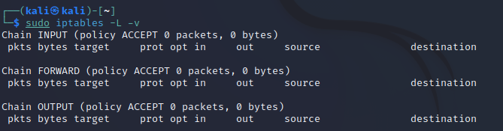**\**

* To enable Firewall perform the following.
  + sudo iptables -P INPUT DROP
  + sudo iptables -P FORWARD DROP
  + sudo iptables -P output ACCEPT

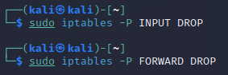



* To block ICMP ping, follow the commands:
  + sudo iptables -A OUTPUT -s 192.168.200.49 -p icmp --icmp-type echo-reply -j DROP

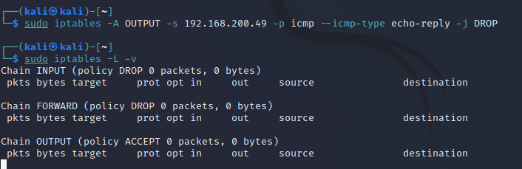

**Allow all outgoing connections**

* Perform the following commands:
  + sudo iptables -A INPUT -s 192.168.200.49 -j ACCEPT

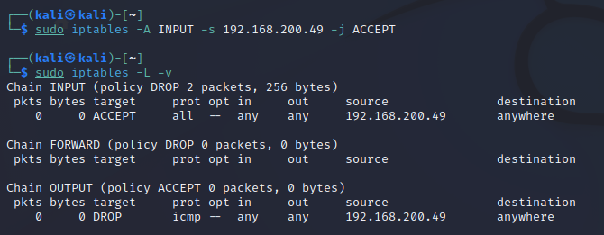

**Block all unwanted incoming connections**

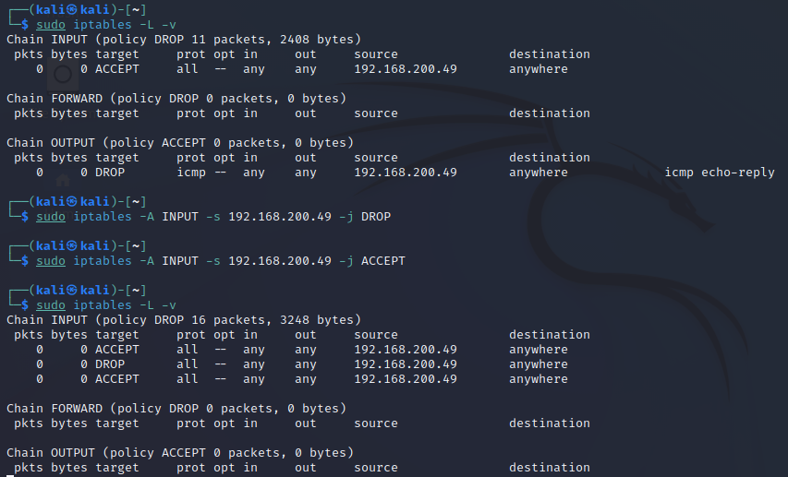

**CONCLUSION**

* In this practical, I learnt how to block ICMP ping using output chain and echo-reply and how to setup SPI firewall.